The lead of the radiation protection door needs to have a certain thickness to prevent radiation

We achieve reliable radiation protection by embedding lead in the cover. As an experienced manufacturer of medical airtight doors and radiation-proof doors, Moenke believes that according to the intensity of radiation, lead inlays need to have a certain thickness. This thickness is decisive for the attenuation level of the radiation protection door, the so-called lead equivalent. With Moencor's radiation protection doors, you can choose between different millimeter lead equivalent values.
The lead door is also called the lead plate door. The lead door is divided into: swing lead door, sliding lead door, revolving lead door, latch lead door and combination lead door.

Open the lead door horizontally
Mainly used in places with weak radiation intensity and air tightness requirements, generally used for personnel entry and exit passages. Such places generally have small shielding layer thickness, small channel size, and high air tightness requirements. The opening method can generally be manually opened.
push-pull lead door
It is mainly used in places where the radiation intensity is relatively strong and there is no air tightness requirement. It is generally suitable for people's mixing passages or the outer doors of special logistics passages. The external space of the channel is large, the thickness of the shielding layer is relatively large, the size of the channel is large, and there is no air tightness requirement. The opening method can generally be opened manually or electrically.
revolving lead door
Rotary radiation protection doors are generally used in places with high radiation intensity and small external fields, and are generally used as protection in radiation emission devices. This place has high dose levels and small space, which is not suitable for installing sliding and flat radiation protection doors.
Plug lead door
The plug-in radiation protection door has a very strong protection ability, which can generally reach a shielding layer with a thickness of several meters. Mainly used for neutron protection or high dose gamma.
combination lead gate
In the design process of the lead door, it can be combined and selected according to the characteristics of different radiation protection doors. For example, it is easy to design the air tightness of the combination of the swing type radiation protection door, and the sliding type radiation protection door is easy to design the shielding requirements, which can not only reduce the design difficulty, but also reduce the investment to a very low level while meeting the process requirements.

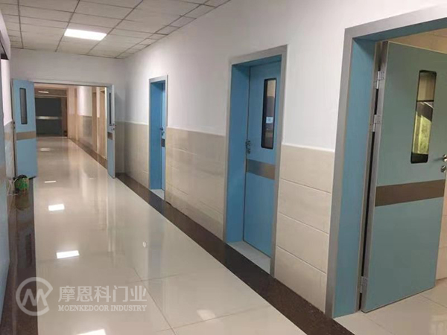

防辐射门的铅需要有一定的厚度才能防辐射

我们通过在盖板中嵌入铅来实现可靠的辐射防护。摩恩科作为经验丰富的医用气密门和防辐射门厂家，认为根据辐射的强度，铅嵌体需要有一定的厚度。这个厚度对于辐射防护门的衰减水平，即所谓的铅当量是决定性的。使用摩恩科的防辐射门，您可以选择不同毫米的铅当量值。
铅门也叫铅板门。铅门分为:平开铅门、推拉铅门、旋转铅门、插销铅门和组合铅门。

水平打开铅门
主要用于辐射强度较弱、有气密性要求的场所，一般用于人员进出通道。这类场所一般屏蔽层厚度小，通道尺寸小，气密性要求高，开启方式一般可以手动开启。
推拉铅门
主要用于辐射强度比较强，没有气密性要求的地方，一般适用于人们的混合通道或特殊物流通道的外门。通道外部空间大，屏蔽层厚度相对较大，通道尺寸大且无气密性要求，开启方式一般可以手动或电动开启。
旋转铅门
旋转防辐射门一般用在辐射强度大、外场小的地方，一般作为辐射发射装置里面的防护。这个地方剂量水平高，空间小，不适合安装推拉式和平板辐射防护门。
插头引线门
插接式防辐射门防护能力非常强，一般可以达到几米厚的屏蔽层。主要用于防中子或高剂量γ的地方。
组合铅门
在铅门的设计过程中，可以根据不同防辐射门的特点进行组合和选择。比如平开式防辐射门的组合选择容易设计气密性，推拉式防辐射门容易设计屏蔽要求，既能降低设计难度，又能在满足工艺要求的情况下，将投资降到很低。

